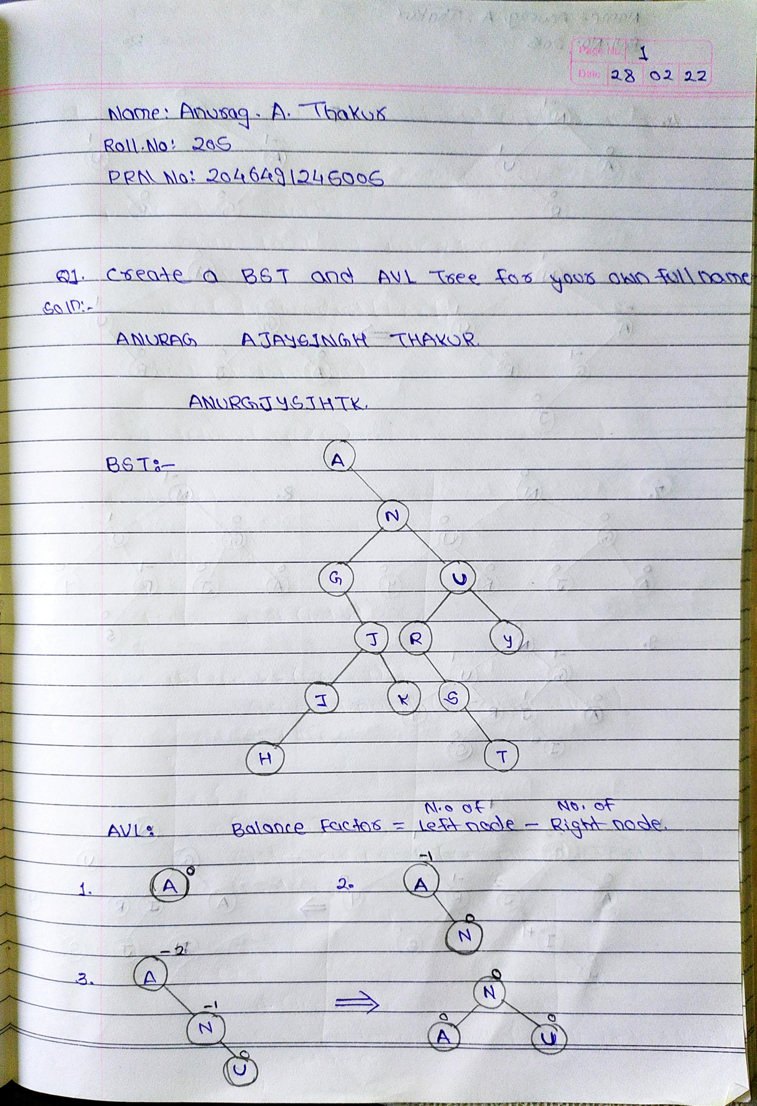

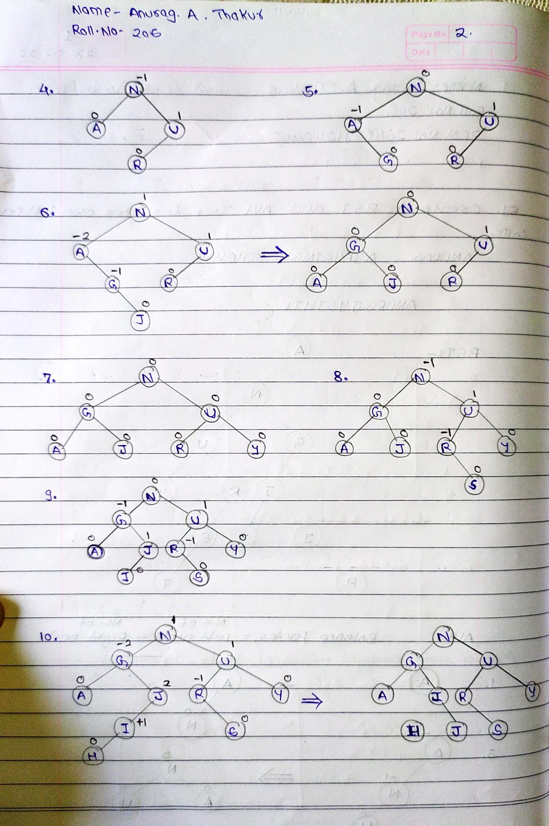

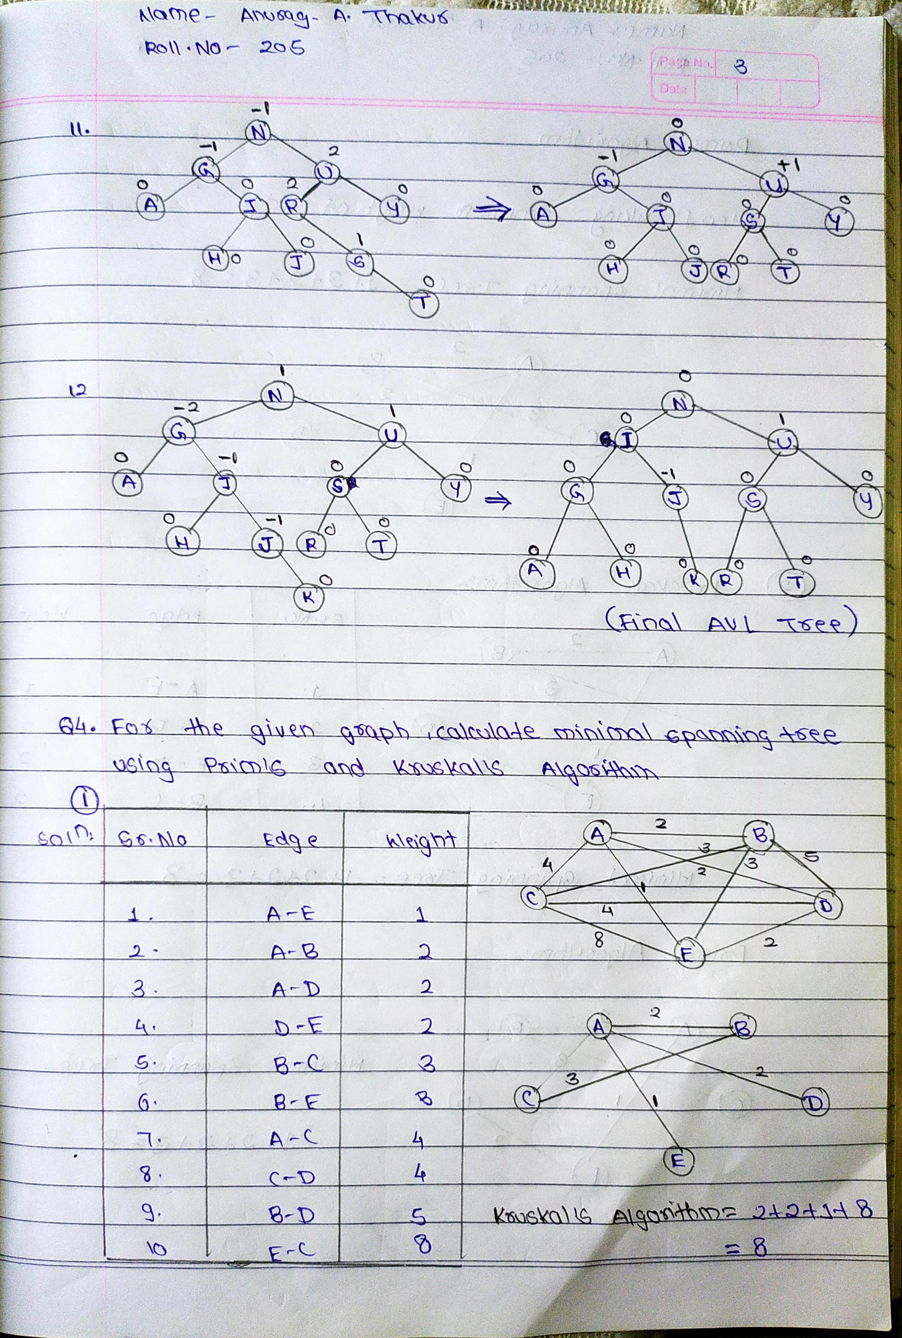

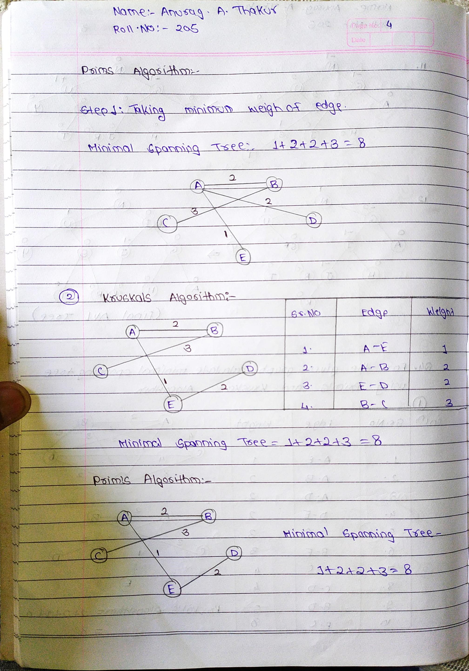

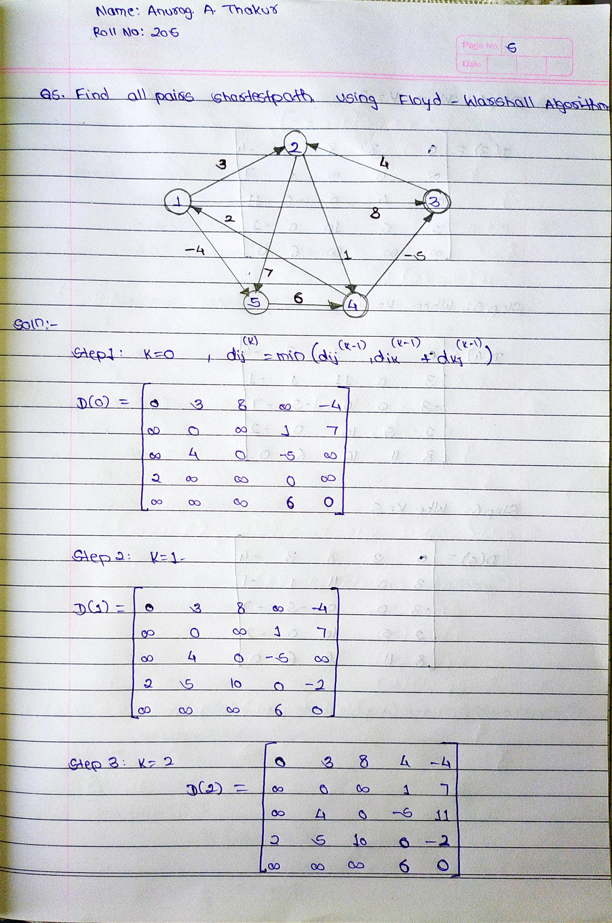

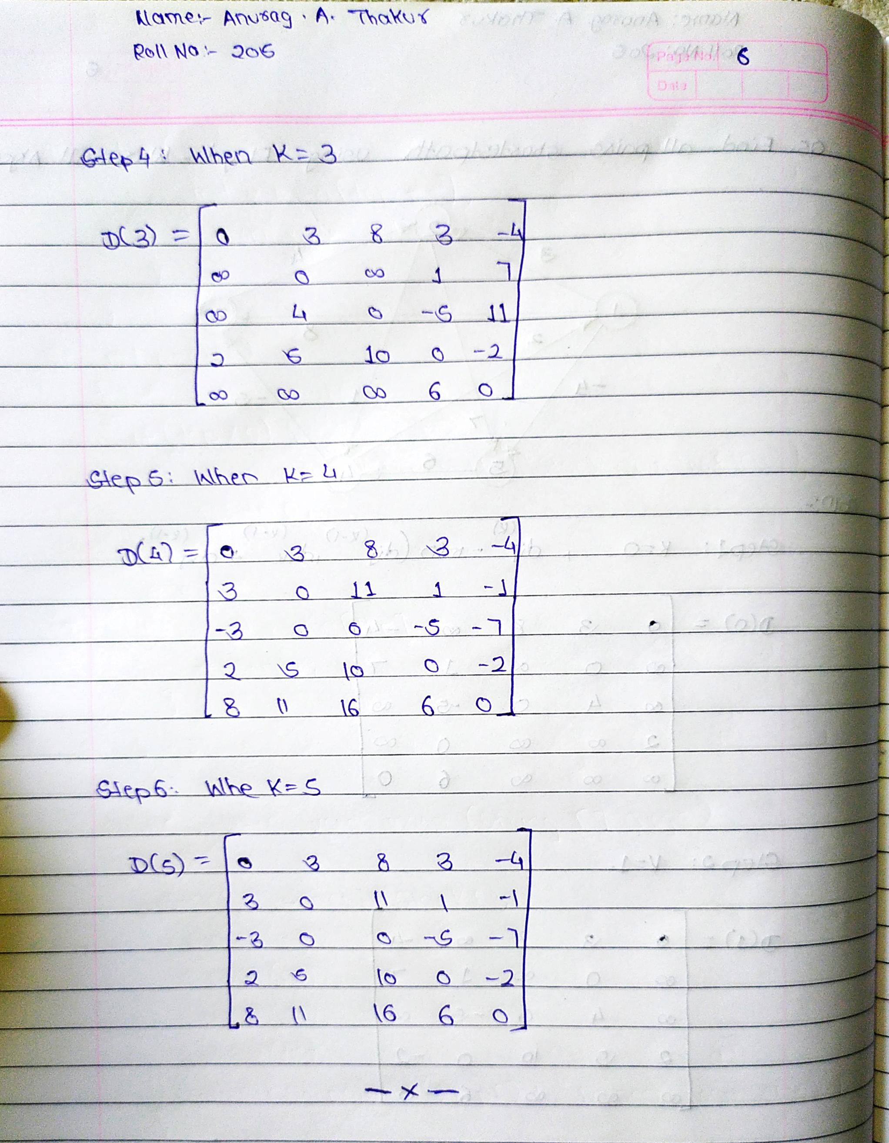

**Q2.Write a non recursive C program to implement inorder , preorder and postorder traversal for a BST.**

**PROGRAM:**

#include<stdio.h>

#include<stdlib.h> #define MAX 50 struct node

NAME:ANURAG A THAKUR

ROLL NO.:205

PRN NO.:2046491245005

{ struct node *left;

int info; struct node *right;

};

struct node *insert(struct node *root, int ele ); void preorder(struct node *root); void inorder(struct node *root); void postorder(struct node *root); void display(struct node *ptr,int level);

struct node *queue[MAX];

int front=-1,rear=-1; void enqueue(struct node *item); struct node *DeQue(); int Qempty();

struct node *stack[MAX]; int top=-1; void Push(struct node *item); struct node *Pop(); int StkEmt();

int main( )

{

struct node *root=NULL;

NAME:ANURAG A THAKUR

ROLL NO.:205

PRN NO.:2046491245005

int x,y, ele; while(y=1)

{

printf("\n 1.Insert"); printf("\n 2.Display"); printf("\n 3.Preorder"); printf("\n 4.Inorder"); printf("\n 5.Postorder"); printf("\n 6.Exit "); printf("\n Choose option:"); scanf("%d",&x); switch(x)

{ case 1:

printf("\nEnter Element : "); scanf("%d",&ele); root = insert(root, ele);

break;

case 2:

printf("\n\t"); display(root,0); printf("\n\t"); break;

case 3:

preorder(root);

break;

case 4: inorder(root); break;

NAME:ANURAG A THAKUR

ROLL NO.:205

PRN NO.:2046491245005

case 5: postorder(root);

break;

case 6: exit(1); y=0;

default:

printf("\nWrong Input!!!x\n");

}

}

return 0;

}

struct node *insert(struct node *root, int ele)

{

struct node *tmp,*p,*ptr;

ptr = root; p = NULL; while( ptr!=NULL)

{ p = ptr;

if(ele < ptr->info) ptr = ptr->left;

else ptr = ptr->right;

}

tmp=(struct node *)malloc(sizeof(struct node)); tmp->info=ele; tmp->left=NULL; tmp->right=NULL; if(p==NULL) root=tmp; else if( ele < p->info ) p->left=tmp; else p->right=tmp; return root;

NAME:ANURAG A THAKUR

ROLL NO.:205

PRN NO.:2046491245005

}

void preorder(struct node *root)

{

struct node *ptr = root; if( ptr==NULL )

{

printf("Tree is empty\n"); return;

}

printf("\n Pre-order : "); Push(ptr); while( !StkEmt() )

{

ptr = Pop(); printf("%d ",ptr->info);

if(ptr->right!=NULL)

Push(ptr->right);

if(ptr->left!=NULL)

Push(ptr->left);

}

printf("\t");

}

void inorder(struct node *root)

{

struct node *ptr=root;

if( ptr==NULL )

{

printf("Tree is empty\n");

NAME:ANURAG A THAKUR

ROLL NO.:205

PRN NO.:2046491245005

return;

}

printf("\n In-order : "); while(1)

{

while(ptr->left!=NULL )

{

Push(ptr); ptr = ptr->left;

}

while( ptr->right==NULL )

{

printf("%d ",ptr->info); if(StkEmt()) return; ptr = Pop();

}

printf("%d ",ptr->info); ptr = ptr->right;

}

}

void postorder(struct node *root)

{

struct node *ptr = root; struct node *q; if( ptr==NULL )

{

printf("Tree is empty\n"); return;

}

q = root; printf("\n Post-order : "); while(1)

NAME:ANURAG A THAKUR

ROLL NO.:205

PRN NO.:2046491245005

{

while(ptr->left!=NULL)

{

Push(ptr); ptr=ptr->left;

}

while( ptr->right==NULL || ptr->right==q )

{

printf("%d ",ptr->info); q = ptr; if( StkEmt() ) return; ptr = Pop();

}

Push(ptr); ptr = ptr->right;

}

printf("\t");

}

void enqueue(struct node *item)

{

if(rear==MAX-1)

{

printf("queue Overflow\n");

return;

}

if(front==-1) front=0; rear=rear+1; queue[rear]=item ;

}

struct node *DeQue()

NAME:ANURAG A THAKUR

ROLL NO.:205

PRN NO.:2046491245005

{

struct node *item; if(front==-1 || front==rear+1)

{

printf("queue Underflow\n");

return 0;

}

item=queue[front]; front=front+1; return item;

}

int Qempty()

{

if(front==-1 || front==rear+1)

return 1; else

return 0;

}

void Push(struct node *item)

{

if(top==(MAX-1))

{

printf("stack Overflow\n");

return;

}

top=top+1; stack[top]=item;

}

struct node *Pop()

{

struct node *item; if(top==-1)

NAME:ANURAG A THAKUR

ROLL NO.:205

PRN NO.:2046491245005

{

printf("stack Underflow….\n");

exit(1);

}

item=stack[top]; top=top-1; return item;

}

int StkEmt()

{

if(top==-1) return 1; else return 0;

}

void display(struct node *ptr,int level)

{ int i;

if(ptr == NULL ) return; else

{

display(ptr->right, level+1); printf("\n\t"); for (i=0; i<level; i++)

printf(" "); printf("%d", ptr->info); display(ptr->left, level+1);

}

} **OUTPUT:-**

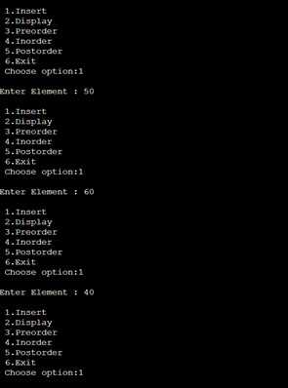

NAME:ANURAG A THAKUR

ROLL NO.:205

PRN NO.:2046491245005

NAME:ANURAG A THAKUR

ROLL NO.:205

PRN NO.:2046491245005

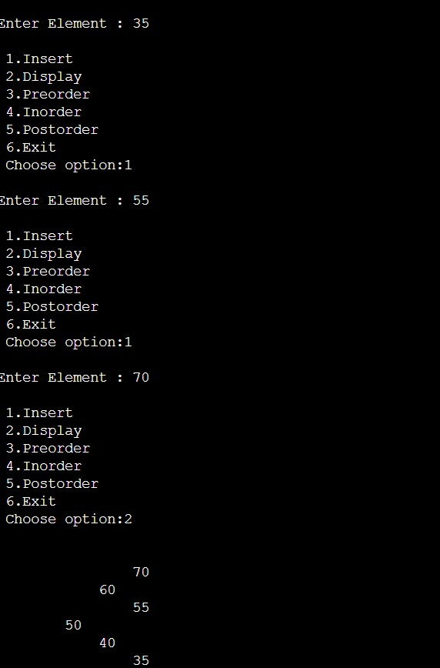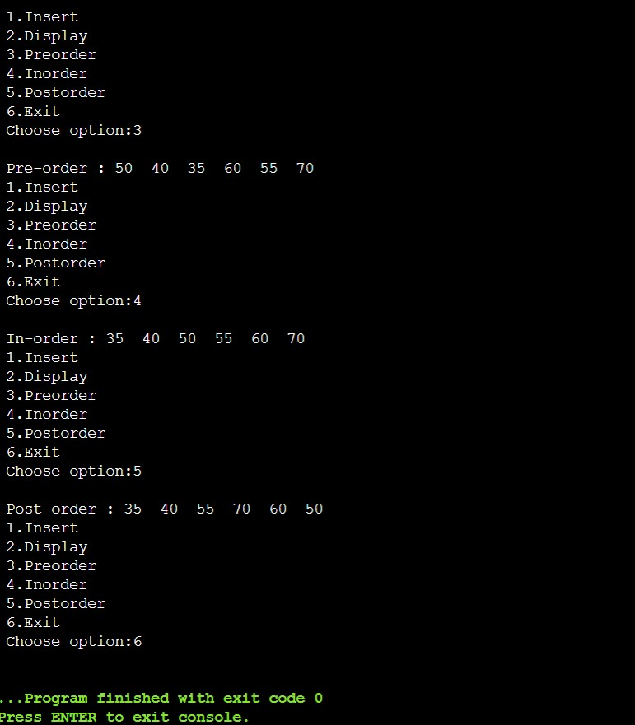

**Q3.Write C program to implement Depth first search and Breadth first search traversals of a graph.**

**BFS PROGRAM:**

#include<stdio.h> #include<stdlib.h> int a[20][20], q[20], visited[20], n, i, j, f = 0, r = -1;

NAME:ANURAG A THAKUR

ROLL NO.:205

PRN NO.:2046491245005

void bfs(int v) { for(i = 1; i <= n; i++) if(a[v][i] && !visited[i]) q[++r] = i; if(f <= r) { visited[q[f]] = 1; bfs(q[f++]);

}

}

void main() {

int v; printf("\n Enter the number of vertices:"); scanf("%d", &n);

for(i=1; i <= n; i++) { q[i] = 0; visited[i] = 0;

}

printf("\n Enter graph data in matrix form:\n");

for(i=1; i<=n; i++) { for(j=1;j<=n;j++) { printf("Enter the number for a[%d][%d]:",i,j); scanf("%d",&a[i][j]);

}

}

printf("\n Enter the starting vertex:"); scanf("%d", &v);

NAME:ANURAG A THAKUR

ROLL NO.:205

PRN NO.:2046491245005

bfs(v); printf("\n The node which are reachable are:\n");

for(i=1; i <= n; i++) { if(visited[i]) printf("%d\t", i); else {

printf("\n Bfs is not possible. Not all nodes are reachable"); break;

}

}

} **OUTPUT:**

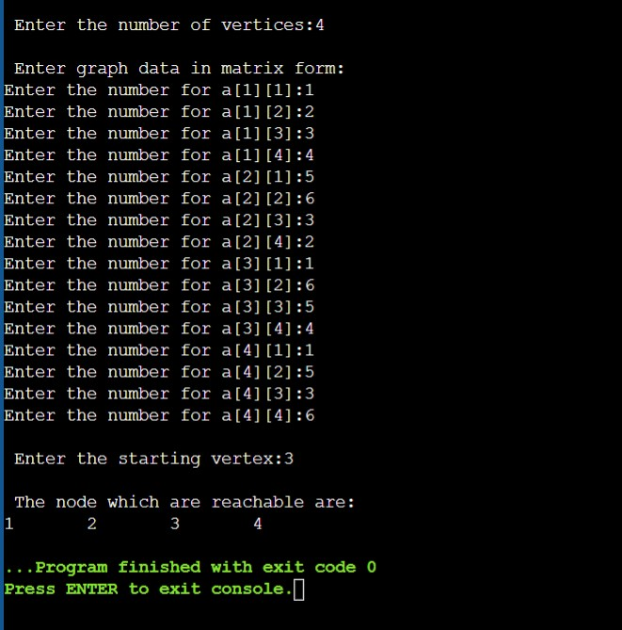

**DFS PROGRAM:**

NAME:ANURAG A THAKUR

ROLL NO.:205

PRN NO.:2046491245005

include<stdio.h> #include<conio.h> int a[20][20],reach[20],n; void dfs(int v)

{ int i;

reach[v]=1; for(i=1;i<=n;i++) if(a[v][i] && !reach[i])

{

printf("\n %d->%d",v,i);

dfs(i);

}

}

void main()

{

int i,j,count=0; printf("\n Enter number of vertices:"); scanf("%d",&n); for(i=1;i<=n;i++)

{

reach[i]=0; for(j=1;j<=n;j++)

a[i][j]=0;

}

printf("\n Enter the adjacency matrix:\n"); for(i=1;i<=n;i++) for(j=1;j<=n;j++) scanf("%d",&a[i][j]); dfs(1);

printf("\n"); for(i=1;i<=n;i++)

{

if(reach[i]) count++;

NAME:ANURAG A THAKUR

ROLL NO.:205

PRN NO.:2046491245005

}

if(count==n) printf("\n Graph is connected");

else printf("\n Graph is not connected");

}

**OUTPUT:**

